**Name:** Vishal Shashikant Salvi.

**UID:** 2019230069

**Class:** SE Comps

**Batch:** C

**Experiment No. 2**

**Aim**: Practicing MySql Fuctions.

**Theory**:

**Aggregate functions in SQL**

In database management an aggregate function is a function where the values of multiple rows are grouped together as input on certain criteria to form a single value of more significant meaning.

**Various Aggregate Functions**

1) Count()

2) Sum()

3) Avg()

4) Min()

5) Max()

Now let us understand each Aggregate function with a example:

Id Name Salary

-----------------------

1 A 80

2 B 40

3 C 60

4 D 70

5 E 60

6 F Null

**Count():**

**Count(*):** Returns total number of records .i.e 6.  
**Count(salary):** Return number of Non Null values over the column salary. i.e 5.  
**Count(Distinct Salary):** Return number of distinct Non Null values over the column salary .i.e 4

**Sum():**

**sum(salary):** Sum all Non Null values of Column salary i.e., 310  
**sum(Distinct salary):** Sum of all distinct Non-Null values i.e., 250.

**Avg():**

**Avg(salary)** = Sum(salary) / count(salary) = 310/5  
**Avg(Distinct salary)** = sum(Distinct salary) / Count(Distinct Salary) = 250/4

**Min():**

**Min(salary):** Minimum value in the salary column except NULL i.e., 40.  
**Max(salary):** Maximum value in the salary i.e., 80.

**Date & Time Functions**

|  |  |
| --- | --- |
| Functions | **Description** |
| [ADDDATE()](https://w3resource.com/mysql/date-and-time-functions/mysql-adddate-function.php) | MySQL ADDDATE() adds a time value with a date. |
| [ADDTIME()](https://w3resource.com/mysql/date-and-time-functions/mysql-addtime-function.php) | In MySQL the ADDTIME() returns a time or datetime after adding a time value with a time or datetime. |
| [CONVERT_TZ()](https://w3resource.com/mysql/date-and-time-functions/mysql-convert_tz-function.php) | In MySQL the CONVERT_TZ() returns a resulting value after converting a datetime value from a time zone specified as the second argument to the time zone specified as the third argument. |
| [CURDATE()](https://w3resource.com/mysql/date-and-time-functions/mysql-curdate-function.php) | In MySQL the CURDATE() returns the current date in 'YYYY-MM-DD' format or 'YYYYMMDD' format depending on whether numeric or string is used in the function. |
| [CURRENT_DATE()](https://w3resource.com/mysql/date-and-time-functions/mysql-current_date-function.php) | In MySQL the CURRENT_DATE returns the current date in ‘YYYY-MM-DD’ format or YYYYMMDD format depending on whether numeric or string is used in the function. |
| [CURRENT_TIME()](https://w3resource.com/mysql/date-and-time-functions/mysql-current_time-function.php) | In MySQL the CURRENT_TIME() returns the current time in ‘HH:MM:SS’ format or HHMMSS.uuuuuu format depending on whether numeric or string is used in the function. |
| [CURRENT_TIMESTAMP()](https://w3resource.com/mysql/date-and-time-functions/mysql-current_timestamp-function.php) | In MySQL the CURRENT_TIEMSTAMP returns the current date and time in ‘YYYY-MM-DD HH:MM:SS’ format or YYYYMMDDHHMMSS.uuuuuu format depending on whether numeric or string is used in the function. |
| [CURTIME()](https://w3resource.com/mysql/date-and-time-functions/mysql-curtime-function.php) | In MySQL the CURTIME() returns the value of current time in ‘HH:MM:SS’ format or HHMMSS.uuuuuu format depending on whether numeric or string is used in the function. |
| [DATE_ADD()](https://w3resource.com/mysql/date-and-time-functions/mysql-date_add-function.php) | MySQL DATE_ADD() adds time values (as intervals) to a date value. The [ADDDATE()](https://www.w3resource.com/mysql/date-and-time-functions/mysql-adddate-function.php) is the synonym of DATE_ADD(). |
| [DATE_FORMAT()](https://w3resource.com/mysql/date-and-time-functions/mysql-date_format-function.php) | MySQL DATE_FORMAT() formats a date as specified in the argument. A list of format specifiers given bellow may be used to format a date. |
| [DATE_SUB()](https://w3resource.com/mysql/date-and-time-functions/mysql-date_sub-function.php) | MySql date_sub() function subtract a time value (as interval) from a date. |
| [DATE()](https://w3resource.com/mysql/date-and-time-functions/mysql-date-function.php) | MySQL DATE() takes the date part out from a datetime expression. |
| [DATEDIFF()](https://w3resource.com/mysql/date-and-time-functions/mysql-datediff-function.php) | MySQL DATEDIFF() returns the number of days between two dates or datetimes. |
| [DAY()](https://w3resource.com/mysql/date-and-time-functions/mysql-day-function.php) | MySQL DAY() returns the day of the month for a specified date. |
| [DAYNAME()](https://w3resource.com/mysql/date-and-time-functions/mysql-dayname-function.php) | MySQL DAYNAME() returns the name of the week day of a date specified in the argument. |
| [DAY OF MONTH()](https://w3resource.com/mysql/date-and-time-functions/mysql-dayofmonth-function.php) | MySQL DAYOFMONTH() returns the day of the month for a given date. |
| [DAY OF WEEK()](https://w3resource.com/mysql/date-and-time-functions/mysql-dayofweek-function.php) | MySQL DAYOFWEEK() returns the week day number (1 for Sunday,2 for Monday …… 7 for Saturday ) for a date specified as an argument. |
| [DAY OF YEAR()](https://w3resource.com/mysql/date-and-time-functions/mysql-dayofyear-function.php) | MySQL DAYOFYEAR() returns day of the year for a date. The return value is within the range of 1 to 366. |
| [EXTRACT()](https://w3resource.com/mysql/date-and-time-functions/mysql-extract-function.php) | MySQL EXTRACT() extracts a part of a given date. |
| [FROM_DAYS()](https://w3resource.com/mysql/date-and-time-functions/mysql-from_days-function.php) | MySQL FROM_DAYS() returns a date against a datevalue. |
| [FROM_UNIXTIME()](https://w3resource.com/mysql/date-and-time-functions/mysql-from_unixtime-function.php) | MySQL FROM_UNIXTIME() returns a date /datetime from a version of unix_timestamp. |
| [GET_FORMAT()](https://w3resource.com/mysql/date-and-time-functions/mysql-get_format-function.php) | MySQL GET_FORMAT() converts a date or time or datetime in a formatted manner as specified in the argument. |
| [HOUR()](https://w3resource.com/mysql/date-and-time-functions/mysql-hour-function.php) | MySQL HOUR() returns the hour of a time. |
| [LAST_DAY()](https://w3resource.com/mysql/date-and-time-functions/mysql-last_day-function.php) | MySQL LAST_DAY() returns the last day of the corresponding month for a date or datetime value. |
| [LOCALTIME()](https://w3resource.com/mysql/date-and-time-functions/mysql-localtime-function.php) | MySQL LOCALTIME returns the value of current date and time in ‘YYYY-MM-DD HH:MM:SS’ format or YYYYMMDDHHMMSS.uuuuuu format depending on the context (numeric or string) of the function. |
| [LOCALTIMESTAMP()](https://w3resource.com/mysql/date-and-time-functions/mysql-localtimestamp-function.php) | MySQL LOCALTIMESTAMP returns the value of current date and time in ‘YYYY-MM-DD HH:MM:SS’ format or YYYMMDDHHMMSS.uuuuuu format depending on the context (numeric or string) of the function. |
| [MAKEDATE()](https://w3resource.com/mysql/date-and-time-functions/mysql-makedate-function.php) | MySQL MAKEDATE() returns a date by taking a value of a year and a number of days. The number of days must be greater than 0 otherwise a NULL will be returned. |
| [MAKETIME()](https://w3resource.com/mysql/date-and-time-functions/mysql-maketime-function.php) | MySQL MAKETIME() makes and returns a time value from a given hour, minute and seconds. |
| [MICROSECOND()](https://w3resource.com/mysql/date-and-time-functions/mysql-microsecond-function.php) | MySQL MICROSECOND() returns microseconds from the time or datetime expression. |
| [MINUTE()](https://w3resource.com/mysql/date-and-time-functions/mysql-minute-function.php) | MySQL MINUTE() returns a minute from a time or datetime value. |
| [MONTH()](https://w3resource.com/mysql/date-and-time-functions/mysql-month-function.php) | MySQL MONTH() returns the month for the date within a range of 1 to 12 ( January to December). |
| [MONTHNAME()](https://w3resource.com/mysql/date-and-time-functions/mysql-monthname-function.php) | MySQL MONTHNAME() returns the full name of the month for a given date. |
| [NOW()](https://w3resource.com/mysql/date-and-time-functions/mysql-now-function.php) | MySQL NOW() returns the value of current date and time in ‘YYYY-MM-DD HH:MM:SS’ format or YYYYMMDDHHMMSS.uuuuuu format depending on the context (numeric or string) of the function. |
| [PERIOD_ADD()](https://w3resource.com/mysql/date-and-time-functions/mysql-period_add-function.php) | MySQL PERIOD_ADD() adds a number of months with a period and returns the value in the format YYYYMM OR YYMM. Remember that the format YYYYMM and YYMM are not date values. |
| [PERIOD_DIFF()](https://w3resource.com/mysql/date-and-time-functions/mysql-period_diff-function.php) | MySQL PERIOD_DIFF() returns the difference between two periods. |
| [QUARTER()](https://w3resource.com/mysql/date-and-time-functions/mysql-quarter-function.php) | MySQL QUARTER() returns the quarter of the year for a date. |
| [SEC_TO_TIME()](https://w3resource.com/mysql/date-and-time-functions/mysql-sec_to_time-function.php) | MySQL SEC_TO_TIME() returns a time value by converting the seconds specified in the argument. |
| [SECOND()](https://w3resource.com/mysql/date-and-time-functions/mysql-second-function.php) | MySQL SECOND() returns the second for a time. |
| [STR_TO_DATE()](https://w3resource.com/mysql/date-and-time-functions/mysql-str_to_date-function.php) | MySQL STR_TO_DATE() returns a datetime value by taking a string and a specific format string as arguments. |
| [SUBDATE()](https://w3resource.com/mysql/date-and-time-functions/mysql-subdate-function.php) | MySQL SUBDATAE() subtracts a time value (as interval) from a given date. |
| [SUBTIME()](https://w3resource.com/mysql/date-and-time-functions/mysql-subtime-function.php) | MySQL SUBTIME() subtracts one datetime value from another. |
| [SYSDATE()](https://w3resource.com/mysql/date-and-time-functions/mysql-sysdate-function.php) | MySQL SYSDATE() returns the current date and time in YYYY-MM-DD HH:MM:SS or YYYYMMDDHHMMSS.uuuuuu format depending on the context of the function. |
| [TIME_FORMAT()](https://w3resource.com/mysql/date-and-time-functions/mysql-time_format-function.php) | MySQL TIME_FORMAT() converts a time in a formatted string using the format specifiers. |
| [TIME_TO_SEC()](https://w3resource.com/mysql/date-and-time-functions/mysql-time_to_sec-function.php) | MySQL TIME_TO_SEC() converts a time value in to seconds. |
| [TIME()](https://w3resource.com/mysql/date-and-time-functions/mysql-time-function.php) | MySQL TIME() extracts the time part of a time or datetime expression as string format. |
| [TIMEDIFF()](https://w3resource.com/mysql/date-and-time-functions/mysql-timediff-function.php) | MySQL TIMEDIFF() returns the differences between two time or datetime expressions. |
| [TIMESTAMP()](https://w3resource.com/mysql/date-and-time-functions/mysql-timestamp-function.php) | MySQL TIMESTAMP() returns a datetime value against a date or datetime expression. |
| [TIMESTAMPADD()](https://w3resource.com/mysql/date-and-time-functions/mysql-timestampadd-function.php) | MySQL TIMESTAMPADD() adds time value with a date or datetime value. |
| [TIMESTAMPDIFF()](https://w3resource.com/mysql/date-and-time-functions/mysql-timestampdiff-function.php) | MySQL the TIMESTAMPDIFF() returns a value after subtracting a datetime expression from another. |
| [TO_DAYS()](https://w3resource.com/mysql/date-and-time-functions/mysql-to_days-function.php) | MySQL TO_DAYS() returns number of days between a given date and year 0. |
| [UNIX_TIMESTAMP()](https://w3resource.com/mysql/date-and-time-functions/mysql-unix_timestamp-function.php) | MySQL UNIX_TIMESTAMP() returns a Unix timestamp in seconds since '1970-01-01 00:00:00' UTC as an unsigned integer if no arguments are passed with UNIT_TIMESTAMP(). |
| [UTC_DATE()](https://w3resource.com/mysql/date-and-time-functions/mysql-utc_date-function.php) | MySQL UTC_DATE returns the current UTC (Coordinated Universal Time) date as a value in 'YYYY-MM-DD' or YYYYMMDD format depending on the context of the function i.e. in a string or numeric context. |
| [UTC_TIME()](https://w3resource.com/mysql/date-and-time-functions/mysql-utc_time-function.php) | MySQL UTC_TIME returns the current UTC time as a value in 'HH:MM:SS' or HHMMSS format depending on the context of the function i.e. in a string or numeric context. |
| [UTC_TIMESTAMP()](https://w3resource.com/mysql/date-and-time-functions/mysql-utc_timestamp-function.php) | In MySQL the UTC_TIMESTAMP returns the current UTC date and time as a value in 'YYYY-MM-DD HH:MM:SS' or YYYYMMDDHHMMSS.uuuuuu format depending on the usage of the function i.e. in a string or numeric context. |
| [WEEK()](https://w3resource.com/mysql/date-and-time-functions/mysql-week-function.php) | MySQL WEEK() returns the week number for a given date. |
| [WEEKDAY()](https://w3resource.com/mysql/date-and-time-functions/mysql-weekday-function.php) | MySQL WEEKDAY() returns the index of the day in a week for a given date (0 for Monday, 1 for Tuesday and ......6 for Sunday). |
| [WEEK OF YEAR()](https://w3resource.com/mysql/date-and-time-functions/mysql-weekofyear-function.php) | MySQL WEEKOFYEAR() returns the calender week (as a number) of a given date. |
| [YEAR()](https://w3resource.com/mysql/date-and-time-functions/mysql-year-function.php) | MySQL YEAR() returns the year for a given date. |
| [YEARWEEK()](https://w3resource.com/mysql/date-and-time-functions/mysql-yearweek-function.php) | MySQL YEARWEEK() returns year and week number for a given date. |

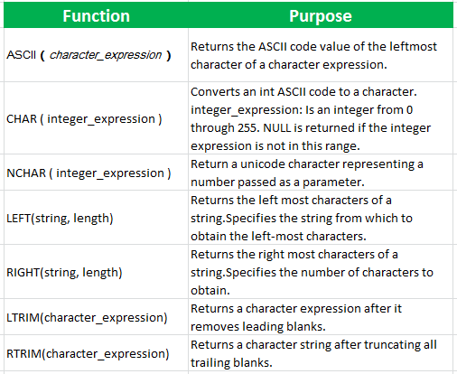

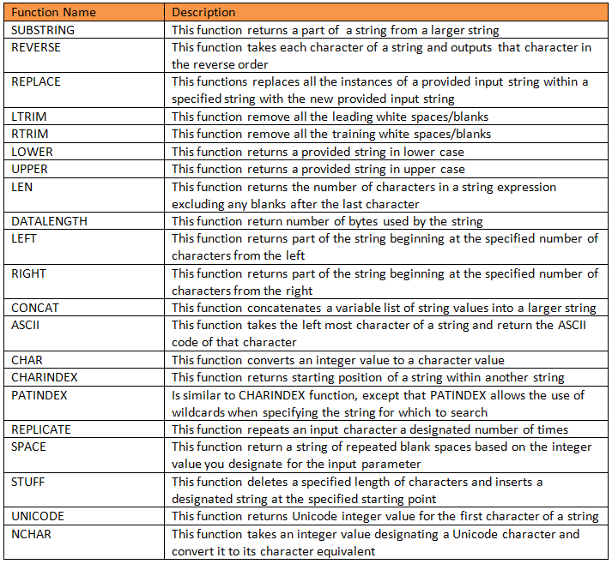

**Output:**

**Aggregate Functions:**

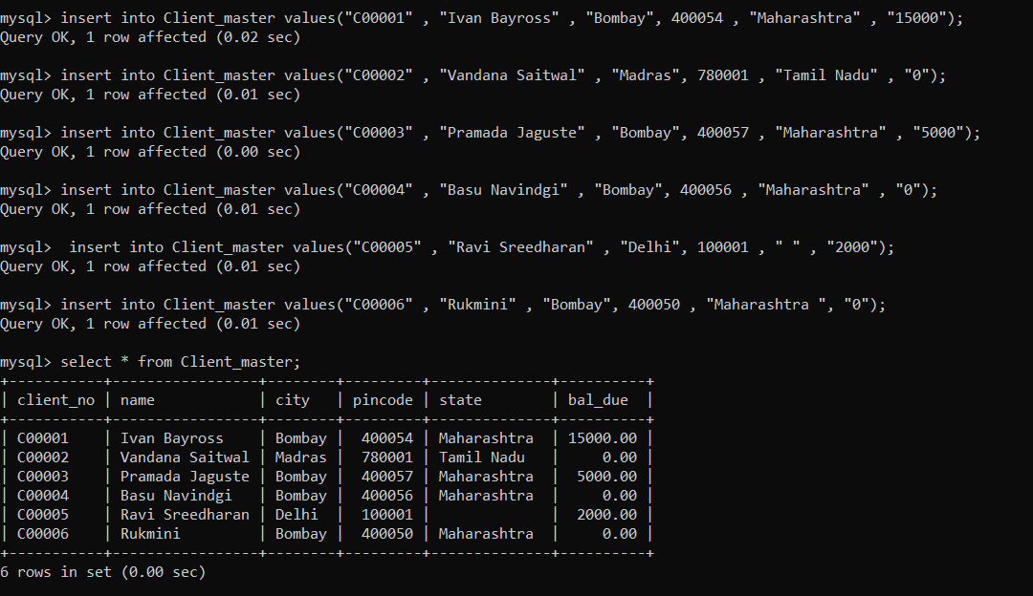

**1)Average**

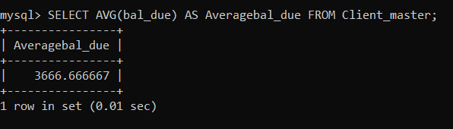

**2)Sum**

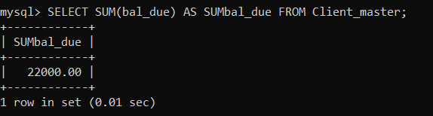

**3)Min**

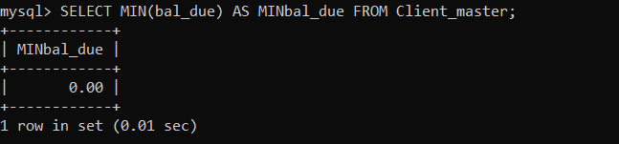

**4)Max**

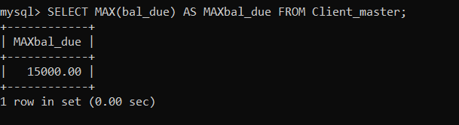

**5)Count**

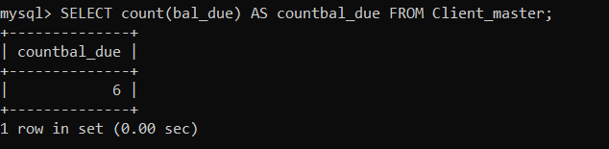

**Date Time Function/ String Operation**

**1)Now()**

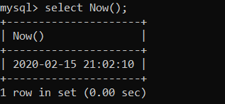

**2)Curtime()**

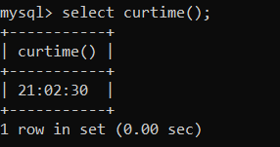

**3)Curdate()**

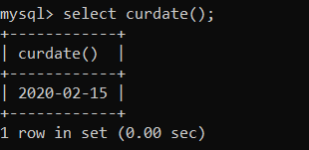

**4)Adddate()**

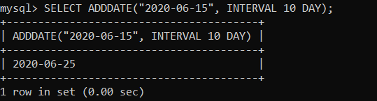

**5)Addtime()**

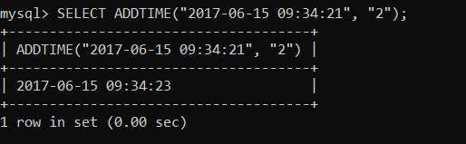

**6)Current_timestamp()**

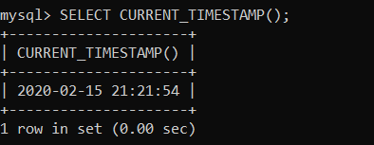

**7)Select Day()**

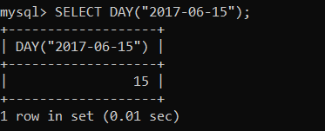

**8)Select Month()**

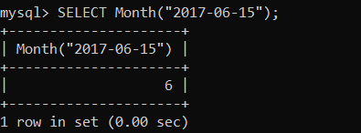

**9)Select year()**

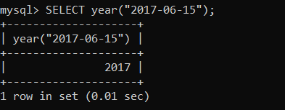

**10)Select Last_day()**

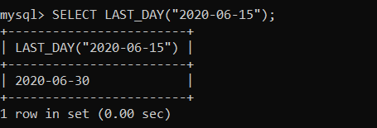

**String operations:**



**1)bit length()**

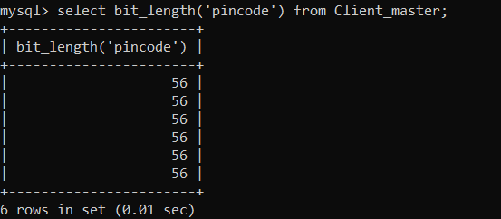

**2)Ascii()**

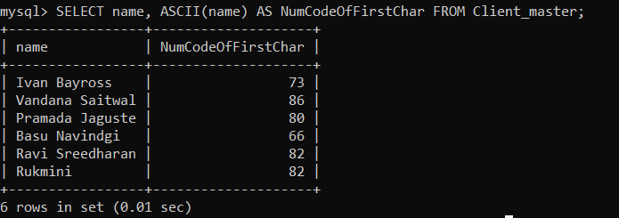

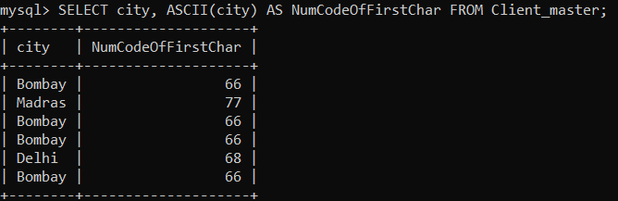

**3)Concat()**



**4)Lower()**

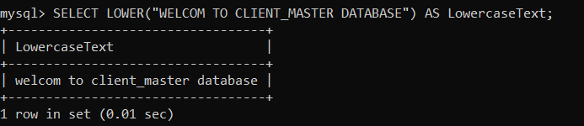

**5)Repeat()**

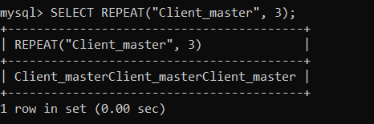

**6)ExtractString()**

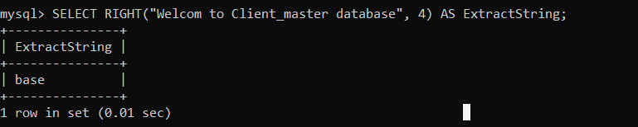

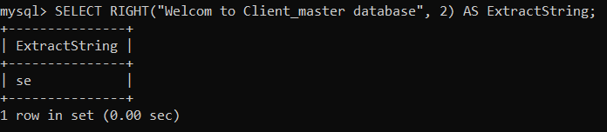

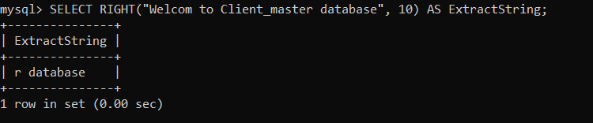

**7)Reverse()**

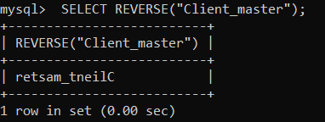

**8)Strcmp()**

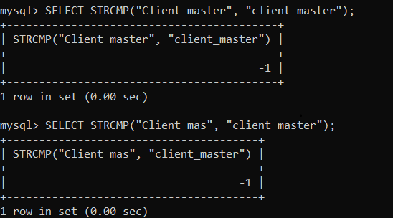

**9)Substring()**

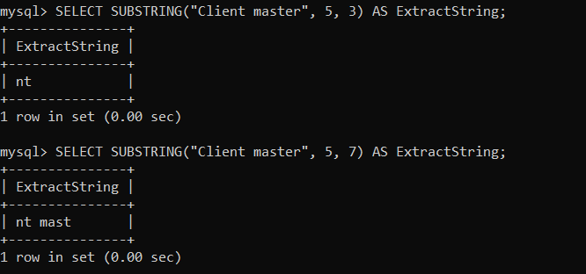

**10)Trim()**

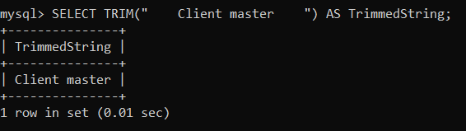

**11)Ucase()**

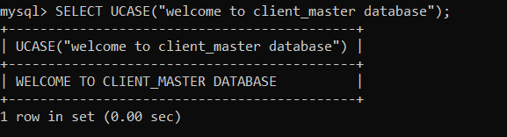

**Five Fuction From Given Assignment.**

**1)Student date:**

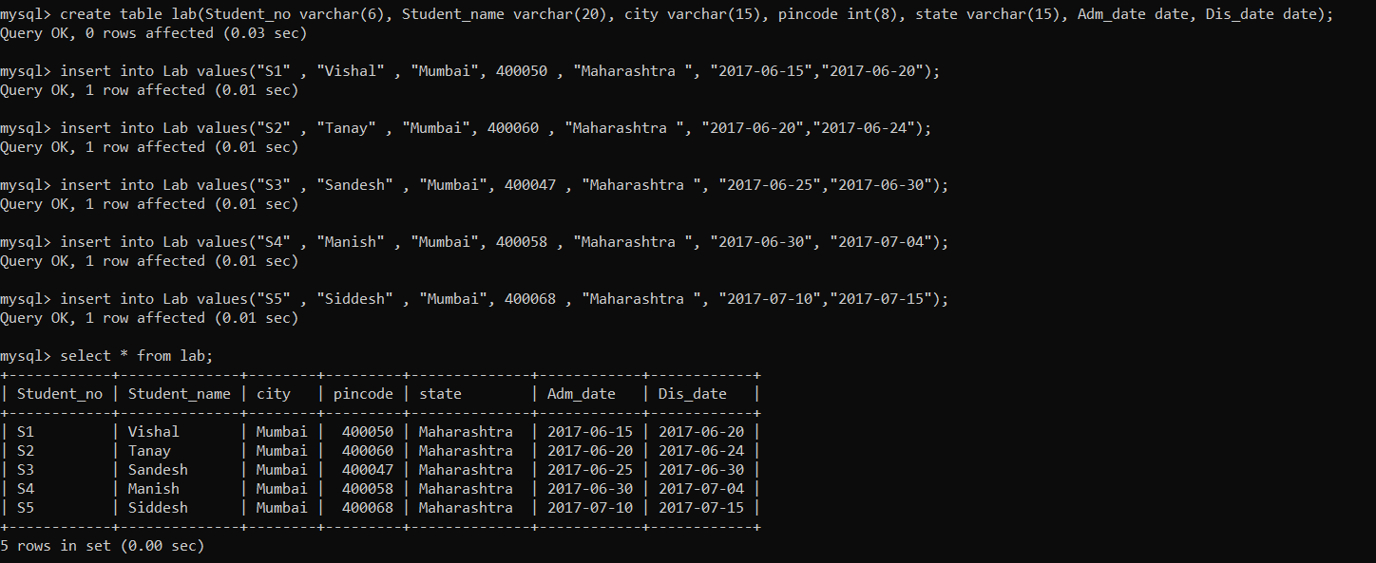

**2)Doctor data**

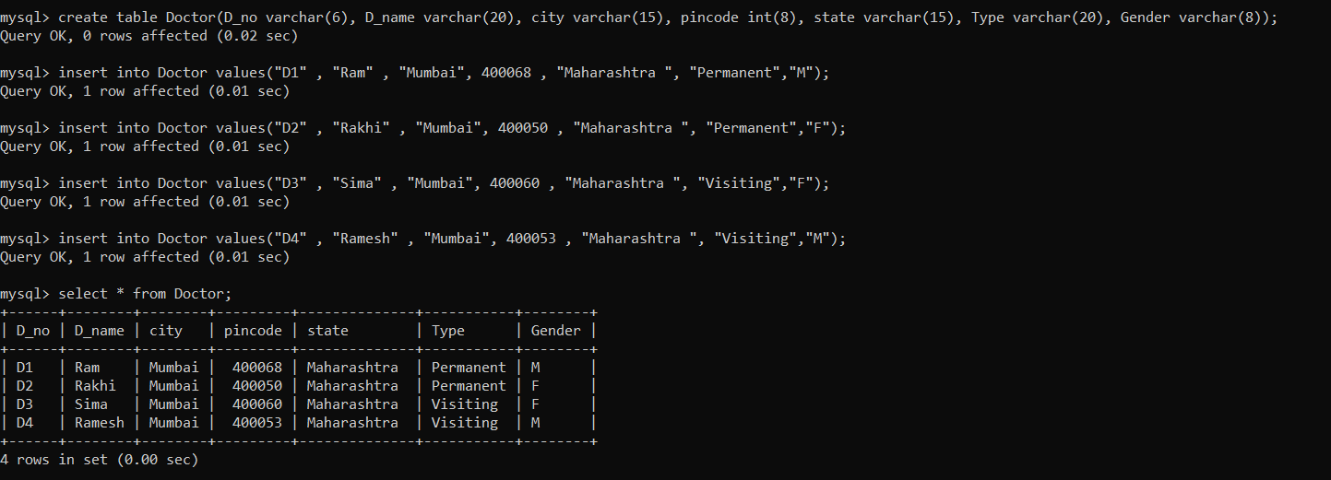

**3)Care taker data**

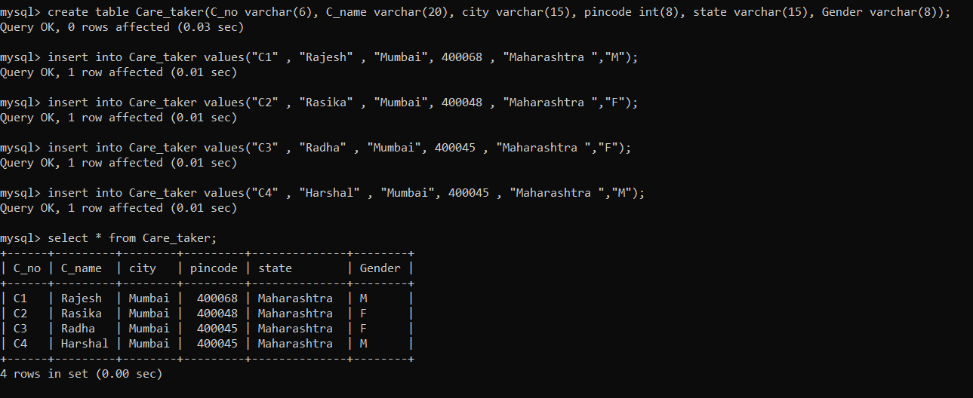

**4)Describe lab**

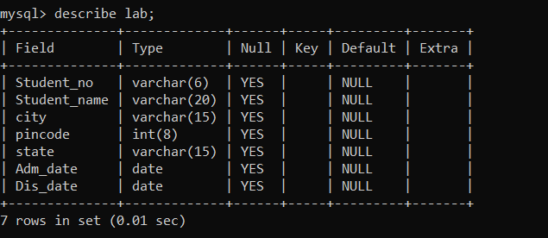

**5) Describe doctor**

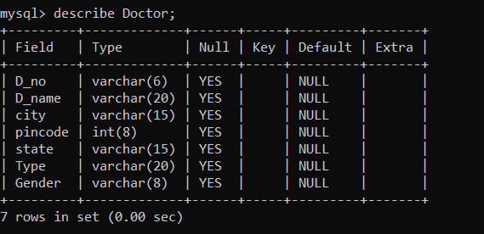

**6) Describe Care taker**

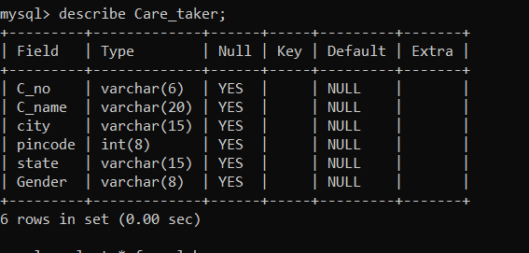

**7)All Hospital syatem**

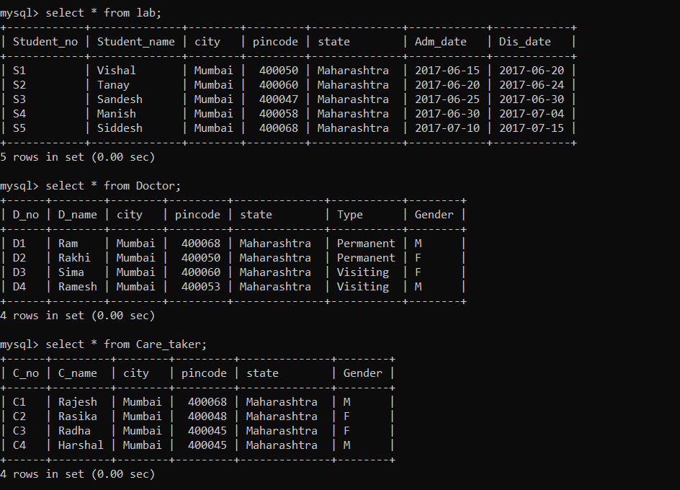

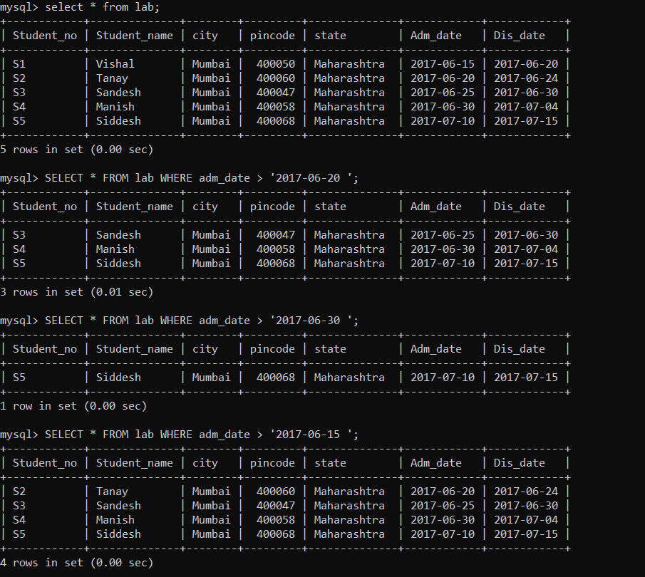

**8)Where**

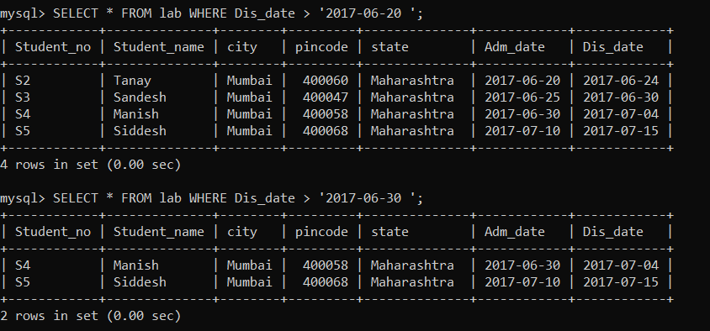

**9)Like r**

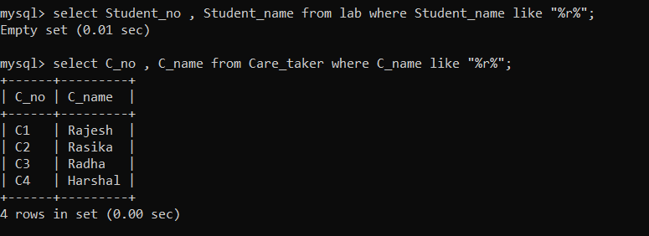

**10)Alter**

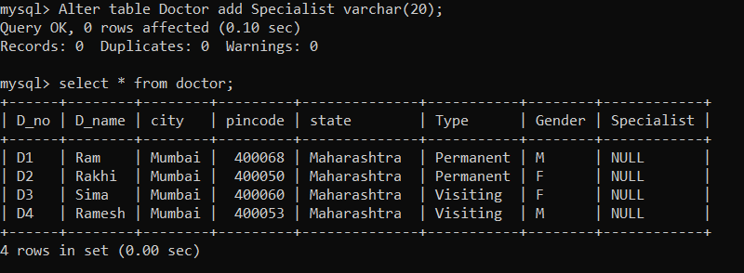

**11)Update**

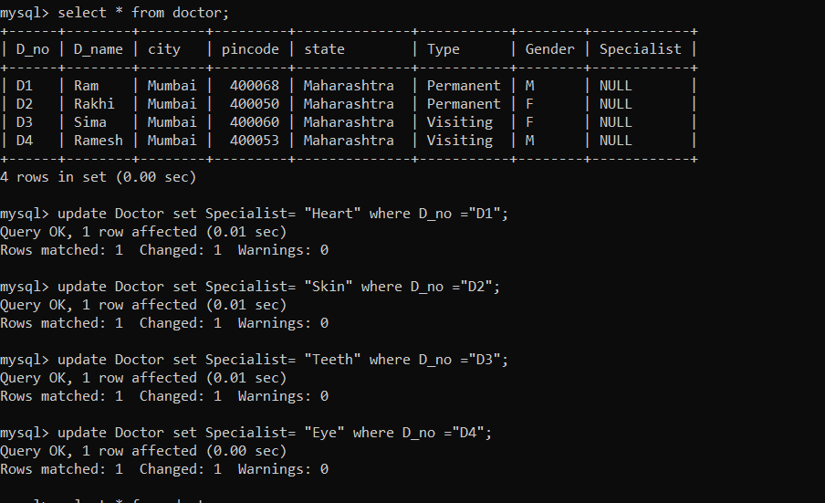

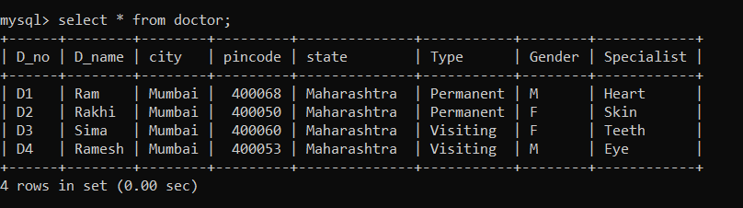

**12)Count**

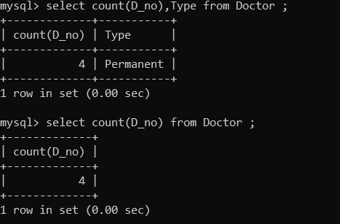

**13)Group by**

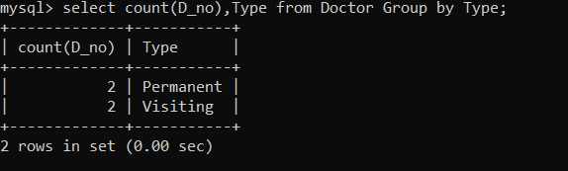

**Conclusion:**

Thus in database management an aggregate function is a function where the values of multiple rows are grouped together as input on certain criteria to form a single value of more significant meaning. Also learn date time function.